**Descriptive Statistics and Time Series Analysis of Datasets**

By Kody Reichert

In this report I will analyze 3 different datasets each containing returns data from different stocks. The three stocks that I chose to compare and analyze are Nike, Adidas, and Under Armour (UAA). They are all athletic shoe and sportswear manufacturing companies that I am considering investing in. So, my question is which company’s stock is in my best interest to invest in. Ideally as a smart investor I would want to maximize my potential returns and minimize potential volatility.

In this report I plan to answer my question by finding the descriptive statistics of each manufacturers returns. Along with these results I will also give economic analysis and interpretation of the data. I will include plots of the monthly returns over the period of June 2006 to December 2018. Additionally, I plan to provide insights to the time series data.

Finally, I will conclude which investment I deem to be the most beneficial to invest in based on all the data and my analysis

**Results and Analysis**

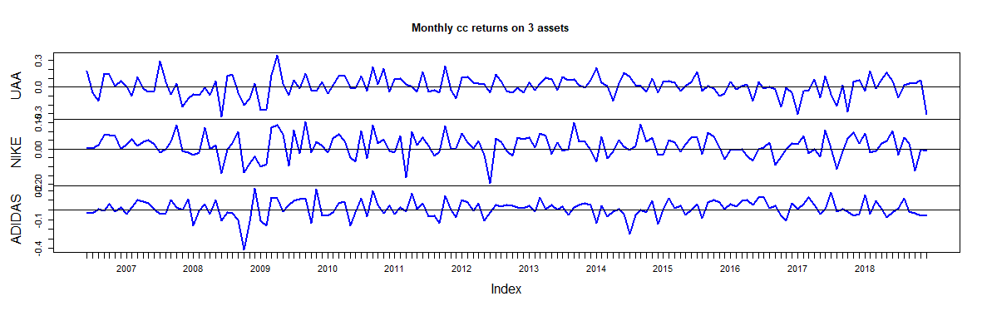Although it may be difficult to see from this chart, Under Armour seems to be the most volatile stock if the three. Good investors want to minimize volatility when possible, so this is not ideal for Under Armour.

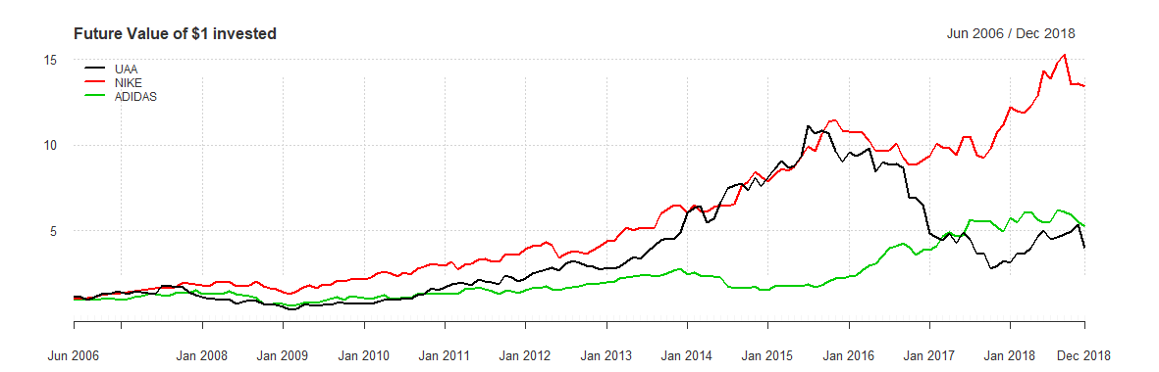

This shows the future values of $1 if it were invested at the beginning of the period. We can see that Nike has the highest Future value of the three while Under Armour and Adidas yield similar results. Ideally, we would have invested in Nike at the beginning of the period if we wanted to maximize our returns.

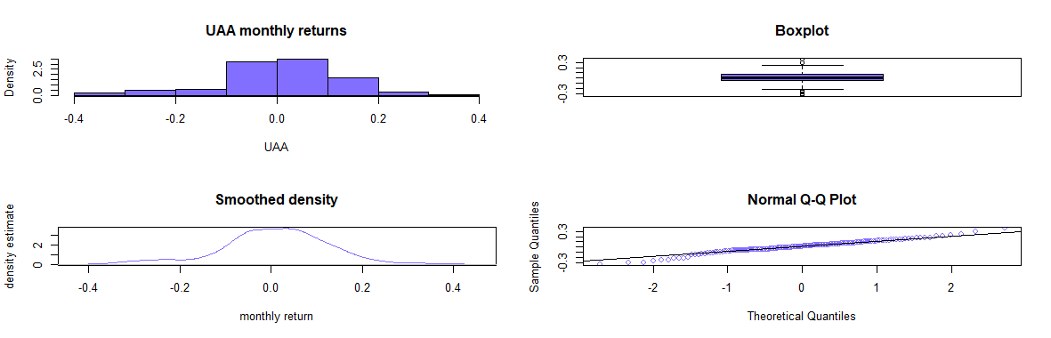

Under Armour’s returns seem to be relatively normally distributed however their tails seem to relatively skewed to the right.

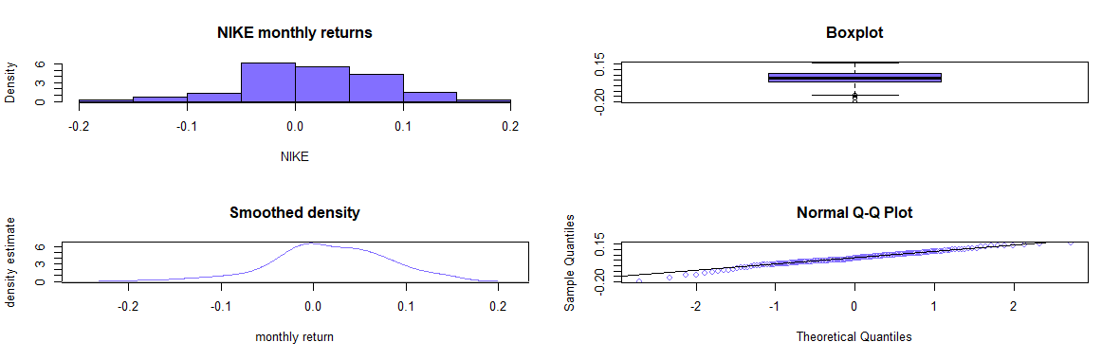

Nike’s return distribution has relatively fat tails and they seem to be skewed to the right.

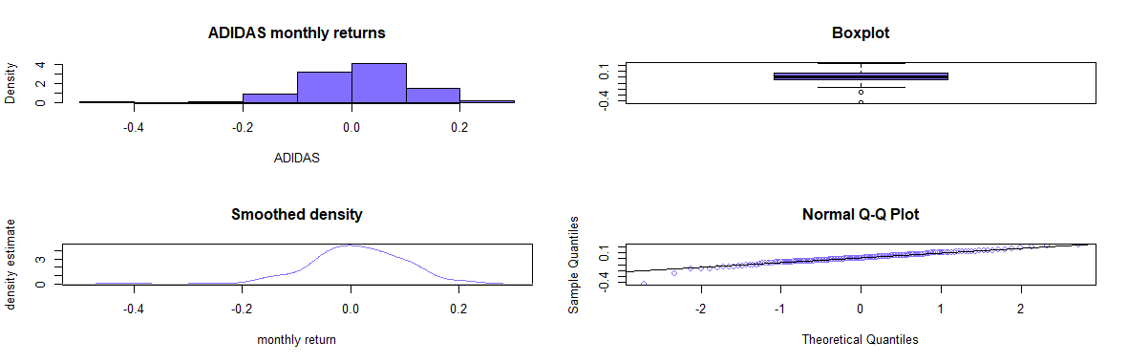I would say that Adidas has the most sharply skewed distribution of the three.

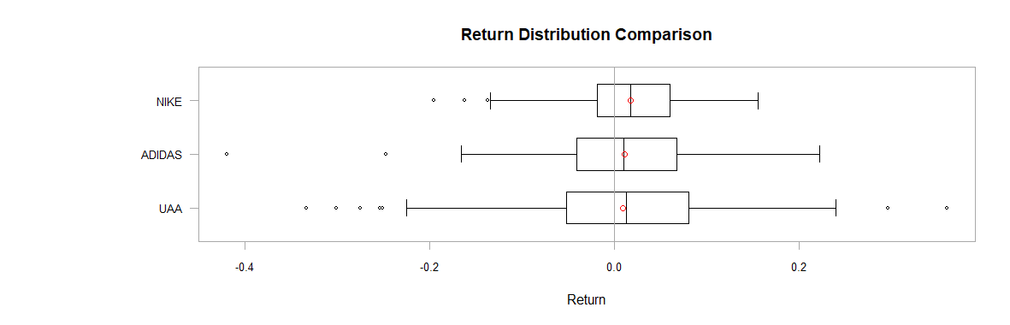

Almost all these stocks have returns above 0 which is a good sign. However, we can clearly see now that Under Armour has the highest variance and is the most volatile of all the stocks. Nike seems to have the greatest returns while adidas seems to have the lowest. A risky investor may consider investing in Under Armour because it is possible that it may have greater returns than Nike. Nike is the clear choice for an investor who wants the safest bet. Under Armour has several positive and negative outliers. Nike seems to have a couple negative outliers. Adidas Has one very significant negative outlier.

UAA NIKE ADIDAS

Observations 151.0000 151.0000 151.0000

NAs 0.0000 0.0000 0.0000

Minimum -0.3338 -0.1956 -0.4193 Adidas has the lowest outlier

Quartile 1 -0.0520 -0.0186 -0.0409

Median 0.0131 0.0171 0.0098

Arithmetic Mean 0.0091 0.0172 0.0110

Geometric Mean 0.0022 0.0152 0.0068

Quartile 3 0.0804 0.0602 0.0677

Maximum 0.3596 0.1554 0.2219 Under Armour has the highest outlier

SE Mean 0.0094 0.0052 0.0073

LCL Mean (0.95) -0.0095 0.0070 -0.0034

UCL Mean (0.95) 0.0277 0.0274 0.0253

Variance 0.0134 0.0040 0.0080 UAA highest variance, Nike lowest

Stdev 0.1156 0.0634 0.0893

Skewness -0.3178 -0.3798 -0.7689 Outlier causing skew for adidas

Kurtosis 0.8458 0.5362 2.8899

ANNUALIZED CC RETURN MEAN

UAA NIKE ADIDAS

0.1094 0.2065 0.1315

Nike has the highest annualize cc returns which is what investors would be Interested in while Under

Armour has the lowest.

SIMPLE ANNUAL RETURN

UAA NIKE ADIDAS

0.1156 0.2293 0.1405

Without Continuously compounding returns Nike would still yield the

greatest return. Under Armour would still have the lowest returns.

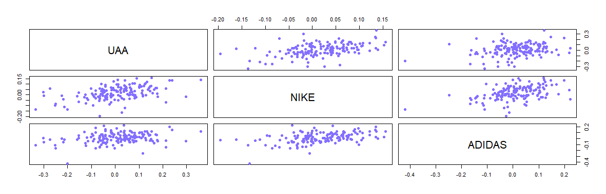

cor(ret.mat)

UAA NIKE ADIDAS

UAA 1.0000 0.4574 0.2673

NIKE 0.4574 1.0000 0.4462

ADIDAS 0.2673 0.4462 1.0000

Under Armour/Nike and Nike/Adidas seem to have relatively strong positive Linear relationships with each other. Adidas and Under Armour seem to have a weak positive liner relationship with each other.

There could be a case for Some of these stocks being correlated with each other, but I don’t believe

there is strong enough evidence to support this.

muhat.vals

UAA NIKE ADIDAS

0.009114 0.017205 0.010959

Nike has the largest mean value, Under Armour the lowest. We prefer Nike

sigmahat.vals

UAA NIKE ADIDAS

0.11557 0.06341 0.08930

Under Armour has the lowest standard deviation. Nike the lowest. We prefer Nike.

se.muhat

UAA NIKE ADIDAS

0.009405 0.005160 0.007267

Under Armour has the highest standard error. Nike the lowest. All

Investments have low standard error so the estimates must be

Precise.

95% confidence intervals:

mu.lower mu.upper

UAA -0.009697 0.02792

NIKE 0.006885 0.02752

ADIDAS -0.003575 0.02549

Under Armour has the highest peak mean and the lowest peak mean at the 95% confidence interval limits. Worth noting that Nike’s lower 25%

Limit is greater than 0. We would expect to make positive returns more

Than 95% of the time which is very desirable.

rho.lower rho.upper

NIKE,UAA 0.3286 0.5861

NIKE,ADIDAS 0.1162 0.4185

UAA,ADIDAS 0.3158 0.5765

At its highest confidence limit Nike/UnderArmour have the highest

possibility of being correlated with each other. While Nike/Adidas

have the lowest possibility.

|  |
| --- |
| Value-at-risk for $100,000 investment  UAA NIKE ADIDAS  -16555 -8340 -12709  Nike has the lowest risk for loss of all three of the stocks.  **Conclusion**  It is clear that it would be most beneficial for me to invest in Nike of all three of these sportswear manufactures. Based on my analysis  they have both the highest returns and the lowest volatility of all  three stocks. If I was not very risk adverse investing in Under Armour could net greater gains than Nike and Adidas. However, most smart  investors would not take this risk and would invest in Nike. |
|  |

|  |  |
| --- | --- |
| |  | | --- | |  | |